How does ‘merch’ play a role in consumer culture and personal identity construction?
Harley Davidson personifies classic Americana, It’s rough, it’s rugged and it’s masculine. Individuals that want to be thought of as rough, rugged and masculine, or feel that they already are and wish to express it, can purchase one of their motorcycles and adopt those attributes as their own. However you cannot drive your motor cycle into the pub or up to your desk in an office job. So then how do you show that you are still a proud member of the Harley Davidson clan? How are people supposed to know what your favourite band is when you can’t play it out loud? How are people going to know that you visited a really cool brewery while traveling through South America if it’s inappropriate to open a can of their IPA on your lunch break? The greater question is why do we need people to know? Why do we need to define what we like and believe ourselves? In this essay I will attempt to answer this question by exploring consumer culture, representation and identity construction with a focus on the equivocal difference between merchandise and ‘merch’.
I have always had an affinity for merch. No trip to the museum or zoo was complete without a commemorative pencil bearing the insignia of the excursion; a hat featuring the loveable company mascot or at the very least a sticker on my shirt advertising where I had visited. To this day I am remised to leave a brewery without at least enquiring if they have stickers to contribute to my ever growing sticker collection or a shirt to add to my overflowing drawers of brewery t-shirts.
While I would be sad to lose any of the brewery t-shirts and jumpers that contribute to at least ninety per cent of my active daywear, the piece I’d be saddest to let go is a fine knit, mustard yellow beanie that I wear unseasonably year round. This hat features an embroidered felt patch with the letters ‘LHG’ enclosed in a black box. This patch represents the small form logo of Left Handed Giant Brewing Co., my favourite brewery from my hometown of Bristol.
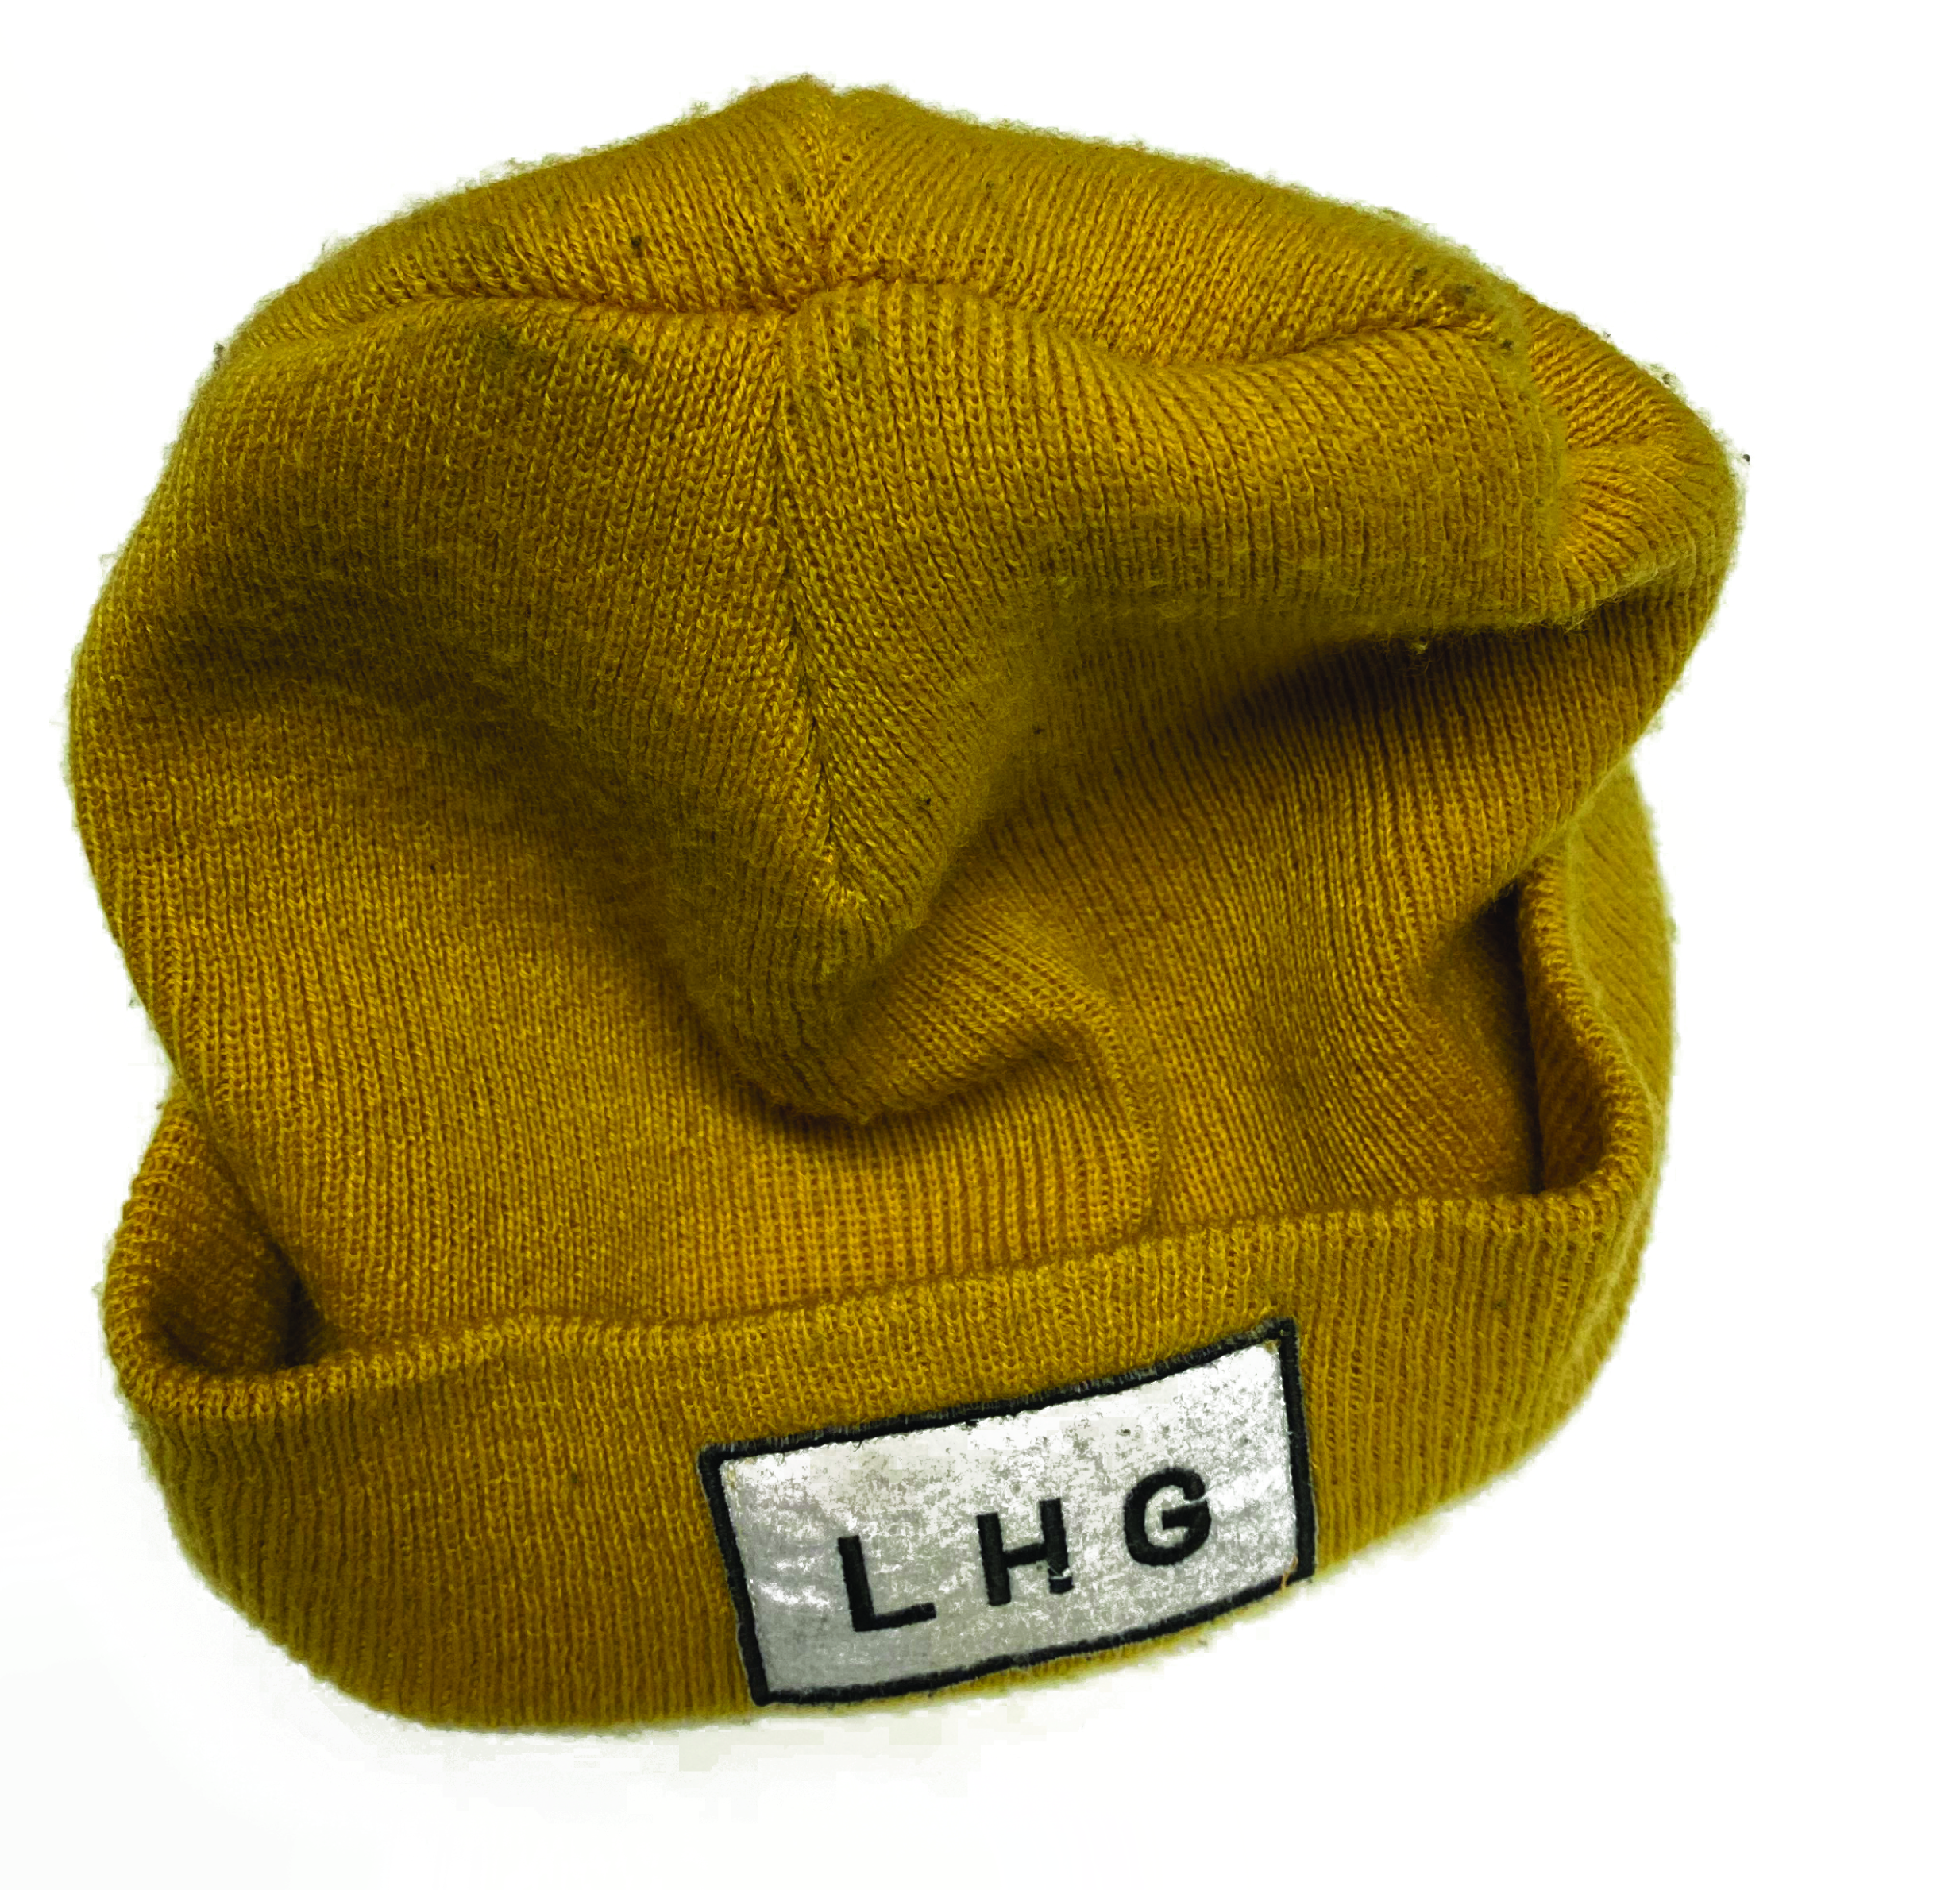
(Picture Credit: Sam Beasor.2020)
As you can ascertain from the name, Left Handed Giant Brewing Co. is a brewery. Their predominant output is beer. They provide kegs of delicious craft ales to bars around the country and their cans can be found all over the world. Beer is their product, it’s what they are known for and it’s what they sell. Beer is their merchandise. Then why am I so enamoured with a yellow beanie that they produced, or a t-shirt, jumper, active wear, glassware or art print (I own them all)?
Craft breweries are not clothing brands, yet all of them seem to have at the very least a t-shirt fort sale. If you browse the LHG website, under the ‘store’ tab you will find two sub tabs, firstly ‘Beer’, compiling all the cans currently available and secondly ‘merch’, offering shirts, jumpers, prints, glassware and hats.
But let’s return to our original example, Harley Davidson. The company is in the business of producing motorcycles, yet they produce so much clothing bearing their logo that they have developed a separate company for it called ‘Motorclothes’. It’s a fair assumption that The Beatles set out to create and sell music, however the amount of mugs adorned with the band’s logo could persuade you into thinking they were a crockery company. All of these items will bring in revenue for the business; however it is not their key product. These shirts, hats, mugs, glasses, prints, pens, badges or stickers are not the merchandise; they are the merch
(Picture Credit: https://lefthandedgiant.com/)
I believe that this prevalence of merch is born out of a demand from the consumer and to understand why, we need to explore identity construction. I have summarised my understanding of identity into the following analogy. Imagine a theoretical document – at the top of this document is the question: “what makes you, you?” Below are questions you’d expect from any boilerplate form: “name, nationality, address, occupation”. Below this reads things like: “Education history, number of dependents, political beliefs”. As the infinite pages continue you would find questions closer to: “What car do you drive, what car would you drive if you could, what is your favourite band?” approaching the esoteric such as “Specific favourite album, would you rather walk on grass or concrete, do you enjoy the smell of petrol, which colour M&Ms do you eat first?” as ridiculous as the questions become, all demand answers and all are intrinsic in determining what makes you, you. ‘Throughout their careers, identities can function as points of identification and attachment only because of their capacity to exclude, to leave out, to render ‘outside’, objected. Every identity has its ‘margin’, an excess, something more. The unity, the internal homogeneity, which the term identity treats as foundational is not a natural, but a constructed form of closure, every identity naming as its necessary, even if silenced and unspoken other, that which it ‘lacks’.’ (Hall. 1996). What makes your infinite document different to others defining your individuality and which questions marry up with others, solidifying your bond?
Imagining this impossible document is an amusing exercise that highlights what the concept of personal identity is and for every question that we have sure-fire answers for, there would be questions that we’d have no idea how to reply to, questions we’d never thought about before or even had any experience with. The knowledge of these gaps in our forms highlights the gaps in understanding ourselves. This makes us feel incomplete. Continuing with my analogy of the infinite document, Stuart Hall, whose theory has been seminal in understanding identity, would argue that the document could never be completed. (In reference to identity) ‘It always remains incomplete, is always ‘in process’, always ‘being formed’[…] Identity arises, not so much from the fullness of identity which is already inside us as individuals, but from a lack of wholeness which is ‘filled’ from outside us.’ (Hall.1996). Hall’s theory on identity construction culminates in three potential concepts of identity, the enlightenment subject, the sociological subject and the post-modern subject.
The enlightenment subject represents identity as being something you are born with: Hall describes this as your core. In relation to my infinite document analogy, we would conclude that the form is already written and decided, the answers do not change and rather than developing the document deciding on answers as we go, instead we are simply discovering what the answers already written are and always have been. The enlightenment subject would argue that I love beer and breweries because I was always going to.
The sociological subject is a touch more reactionary. Hall claims that our personal identities in this manner are created in response to the society and environments we participate in. Our core is slightly more malleable but yet is driven by external factors that we have no direct control over. Our infinite document still comes pre-written for us to discover however large sections of it are written by the things that surround us. The sociological subject argues that I love beer and breweries because I was surrounded by it.
The post-modern subject is the most fluid. It argues that not only are we writing our documents as we live our lives but also that we have the ability to re-write answers as we progress. The Post-modern subject argues that I love beer and breweries because I have made a conscious, rational decision that it aligns with my beliefs. The post-modern subject also claims that I maintain the ability to change my mind in the future if I change who I am or if who I am in the future doesn’t like beer or breweries.
Whichever subject you subscribe to or believe to be correct they all convey the need to discover who we are and fill out or reveal large areas of our infinite documents. Zygmunt Bauman (1996) provides some insight into why we need to construct or reveal ourselves in the first place, ‘One thinks of identity whenever one is not sure of where one belongs, that is, one is not sure how to place oneself among the evident variety of behavioural styles and patterns, and how to make sure that people around would accept this placement as right and proper, so that both sides would know how to go on in each other’s presence. Identity is a name given to escape sought from that uncertainty.’ Much like how Hall would argue that we construct our identities to make sense of a complicated world, ‘culture comes into play at precisely the point where biological individuals become subjects, and that what lies between the two is not some automatically constituted ‘natural’ process of socialisation but a much more complex processes of formation’ (Hall, 1999). Hall even goes as far as to claim that we don’t even become subjects in need of an identity until we begin to interact with culture and society.
Simply scratching the surface of consumer culture we can start to see how the procurement and interaction with certain goods and services can help make sense of the world we reside in as it begins to fill in, or reveal, large sections of our infinite documents.
You may not think at first that any theory developed in regards to consumerism and consumer culture pre- the industrial revolution would hold much weight today. The way we buy things and the things we buy have immensely changed, however the psychology behind why we make these purchases hasn’t. Adam Smith wrote The Wealth of Nations in 1776, which provides an insight into consumerism that’s just as relevant today if not more so, showing that while societies and cultures can be immensely different what psychologically drives our purchases remains the same.
Most countries in the world now live in a consumer culture; we are driven by products, services and goods. It contributes to our economy, promotes trade with others and governs the basis of most of our wants and desires. Where town centres once idolised great minds or religious figures with statues and sculpture, in their places now stand large billboards and advertising materials. Smith carried out his writings during a time when the world wasn’t as complicated, in fact it was around the time of the first consumer revolution where launch of industry made consumables more prevalent and affordable. The common people for the first time not only could afford to buy frivolous things but were being provided with choice.
(Picture Credit: Bradley Hebadon.2019)
Smith’s works question what people buy in terms of their needs. Smith acknowledges that we need to buy food and shelter to survive but in the growing consumer revolution it was falling to trend and popularity as to which foods you bought, how your shelter was decorated and by the purchasing of frivolous items that you could argue you don’t need in the first place. In modern times large companies and sections of our economy are dependent on the production and mass-consumption of these frivolous items, seasonal clothing, extravagant foods and potentially even to my own dismay: beer. While back in 1776 Smith foresaw this and was concerned. Leading theory at the time suggested by Bernard Mandeville in The Fable of the Bees (1714) claimed that we as a people can either chase vanity and indulgence in consuming products and wealth or we can pursue enlightenment and virtue. Mandeville saw the two as distinct opposites. Smith however while agreeing that virtue, education and bettering ourselves were more desirable traits than vanity and frivolity, didn’t quite see them as opposites. Smith in fact saw the benefit, for every company starting to produce products; the poor were given opportunity to work. For every company that benefited from mass-consumption of “sub-optimal purchases”, the economy flared from wealth, benefitting schools and hospitals. ‘Consumption is the sole end and purpose of all production; and the interest of the producer ought to be attended to, only so far as it may be necessary for promoting that of the consumer.’ (Smith.1776). While Smith was less than happy with certain markets, he did see the growth of the Edinburgh Book trade as beneficial and was optimistic that this consumer revolution could be guided into benefiting our higher needs of education and self-understanding rather than frivolous endeavours.
You could easily make the argument that most of the goods and services produced today do not directly relate to our higher needs, however you can see that they provide work, purpose and ultimately a framework in which to construct an identity. Mike Featherstone at a glance seems to be taking a very different stance however he has arrived at the same conclusion as Smith. ‘One’s body, clothes, speech, leisure pastimes, eating and drinking preferences, home, car, choice of holidays, etc. are to be regarded as indicators of the individuality of taste and sense of style of the owner/consumer. In contrast to the designation of the 1950s as an era of grey conformism, a time of mass consumption, changes in production techniques, market segmentation and consumer demand for a wider range of products, are often regarded as making possible greater choice (the management of which itself becomes an art form).’(Featherstone.2007) While both Featherstone and Smith argues that purchasing products has always been an outlet to define one’s self, Featherstone identifies this as a change only offered post 1950 by the increase of choice in purchases and mass production of trivial, non-necessary items.
‘To use the term ‘consumer culture’ is to emphasise that the world of goods and their principles of structuration are central to the understanding of contemporary society. This involves a dual focus: first, on the cultural dimension of the economy, the symbolisation and use of material goods as ‘communicators’ not just utilities; and second, on the economy of cultural goods, the market principles of supply, demand, capital accumulation, competition and monopolisation which operate within the sphere of lifestyles, cultural goods and commodities’. (Featherstone.2007). Featherstone’s definition of consumer culture helps bring together Hall’s theory of how identity helps us find our place in society, Smith’s thoughts on how consumerism can be positive and supports my findings so far that we can use purchases as “Communicators” to express our identities and that consumer culture in its self helps us to find not only a spiritual or mental place within society but also a physical one with production and trade providing people with employment and purpose.
Much like how we create our own personalities to find our way within society, Martin Nuemeier (2006) claims that ‘People create brands to bring order out of clutter.’ In essence with so many companies and services all providing very similar things we need a way to tell them apart, to identify which we identify with. ‘A brand is a person’s gut feeling about a product, service, or company’(Nuemeier.2006) I would argue that a gut feeling is making decisions based on what we already intrinsically believe to be right. What contributes to these beliefs but the answers on our infinite document? So in this regard our feeling about a brand is determined by what we already know about ourselves and if the brand aligns with that.
We have established that I choose to identify with certain breweries because they share my ideals, thoughts and feelings, or help me answer questions about myself that I’d never thought to ask. Also now that I have these answers and they have become part of my core, they are necessary in helping me navigate society and find my place and role within it; however it is not always appropriate for me to be in an environment such as a brewery or to be consuming alcohol. I propose that this is the exact purpose and need for merch. Without my yellow hat proudly sporting my affinity for LHG I’d have to interact with the world with whole pages of my infinite document redacted, hidden away and of no use. People that share my infatuation with beer and breweries would have no visual signifiers to identify me as an equal, ‘Symbols are words, gestures, pictures, or objects that carry a particular meaning that is recognized as such only by those who share the culture.’ (Hofstede.2010). Colleagues wouldn’t be able to assume that my allegiance to an independent brewery stems from a want to support a local business that maintains good working conditions for their staff.
Assuming that people would draw these conclusions from a shirt that I am wearing or a hat on my head might be a bit of a stretch, but it does help me to realise my own reasons for choosing the hat and for wearing it so proudly. By helping me to internally answer questions about myself; by providing me with merch as a tool to externally express my beliefs; my identity is justified and adequately expressed. In an attempt to expand on consumer culture Celia Lury (2011) further defines the subset of physical items and there role as ‘material culture’ which further supports my assumptions on the importance of merch in identity construction, ‘one of the most important ways in which people relate to each other socially is through the mediation of things’(Lury.2011).
An interesting quote included in Creating a Brand Identity (Slade-Brooking.2018) from infamous designer Walter Landor; ‘Products are created in a factory; brands are created in the mind’. I deconstruct this fantastic sentence to mean that products are tangible physical things we can obtain, for example a can of Coca-Cola, however the branding that comes with them and leads to our purchase of Pepsi over Coca-Cola is our personal relation to that brand, which exists beyond the product and what exists in the mind driven by our understanding of ourselves. If our personal relationship with Pepsi or Coca-Cola is driven by our core, by our identity, the answers on our infinite documents, simply purchasing a can of the beverage is not enough. To further express our alignment with the brand and what it stands for we need something more permanent than a consumable. We need objects that Lury describes as ‘artefacts which act as totems’. Lury describes our desire for material goods as a ‘Desire for control over the social environment’. I don’t quite subscribe in the same way that Lury does that we have a deep need to control society, but this view definitely aligns with Hall’s theory on identity being born out of a need to participate in society. Whether for participation or control, Lury makes good use of Marxism to explain our facilitation of and approach to material goods. Lury quotes Leiss et al (1986) to express the ineffable quality that Marx suggests materials possess infused in them by the brand, ‘Goods reveal or ‘show’ to our senses their capacities to be satisfiers or stimulators of particular wants and communicators of behavioural codes. At the same time they draw a veil across their own origins. Products appear and disappear before consumers’ eyes as if by spontaneous generation, and it is an astute shopper indeed who has much idea about what most things are composed of and what kinds of people made them.’ We the authors of our infinite document can see what is infused in the brand and whether we align with it, further more deciding if we allow those encoded messages to define us.
A.W.Thomas and W.H Cunningham (1972) conducted a study on the products that people purchased and what lead the decision to purchase that rather than a competitor. The study concluded that social status and income lead to less responsibility taken in the items they chose. While certain items may not have been ecological sourced, ethical or cruelty free, consumers felt that their low income was the cause of such purchases and wrote off any feeling of guilt as a result of their income and societies impact on them. More affluent consumers who could afford to spend more on the items they purchased took pride in doing so, allowing the purchase to contribute to their identity advertising the positive choices they had made in their spending. Livingstone and Lunt (1992) expand on this idea that a symbiosis exists between our beliefs and our purchases by agreeing with my current stance that ‘Consumer culture provides the conditions within most people work out their identities’ and supporting Thomas and Cunningham by concluding that: ‘More specific consumer groups exercise some political power at the point of consumption […] using consumer boycotts […] and selective buying’. (Livingstone and Lunt. 1992).
I know that a key contributing factor to why I purchase beer from independent craft breweries rather than commercial competitors is because I can see what my money supports and where it goes and I will wear my yellow beanie advertising that support. However, I am happy to buy a cheap loaf of Hovis over a loaf from a local independent bakery without the need to express my support of Hovis or lack or support for a local bakery. “It is not from the benevolence of the butcher, the brewer or the baker that we expect our dinner. But from their regard for their own self-interest.” (Smith. 1776). The purchases we make as consumers whether directly in our control or not can affect our identities only if we allow them to, this makes a case for the argument that our decisions guide our purchases rather than our purchases guiding us.
Identities can come pre-composed or be largely revealing. We have a basic need to feel whole. Our opinions, beliefs, ideals, likes and dislikes all fill out a theoretical “Fill in the blanks” style document called “What makes you, you?”. Knowledge that this theoretical list exists and remains relatively empty can rather disconcertingly cause us to also feel empty, blank or un-whole. Adopting or advertising pre-composed identities we can fill in large portions of these lists at a time.
‘Cultures are to society what personality is to individuals.’ (Hofstede.2010). Within consumer culture brands construct their identities in a very similar way to how we construct our personal identities, with infinite lists as long as our own, filled in by pre-existing traits already inherent in consumer culture. Consumers can adopt the same characteristics expressed by brands through purchasing their products or merchandise, outwardly expressing the same attributes themselves. When it is not appropriate to indulge in these products we can show our alignment with their merch.
While the etymology of the word ‘brand’ stems from branding cattle, I do not believe that branding in the modern sense is a company’s veiled claim of ownership over the consumer. For a start the adornment and adoption of brands is a conscious choice by the consumer, also we have established that if we do not wish to allow a purchase to define us, we won’t. Instead the adoption of certain brands over another is an expression of one’s self. ‘Becoming what one is, is a creative act comparable with creating a work of art’ (Storr.2015). I agree with Featherstone that constructing an identity is an art form and incredibly complex. Becoming you is something that literally takes your entire life, relying on identity construction, consumerism, consumer culture, material culture and a symbiotic interaction with society.
Whether you agree with the conclusion of this essay is now another question on your infinite document. Your answer to that question will be driven by other answers on your infinite document that contribute what you believe to be right or good, not just morally but in personal taste. Every item of clothing you choose to wear is pre-programmed with how the society you reside in will interpret that item. Whether a completely plain white t-shirt or a severely worn band t-shirt from a gig you attended 8 years ago, each display a message to those you will come into contact with. The messages programmed into company merch are more exaggerated and clear due to a pre-understanding of the company’s ideals. We as consumers can employ this merch to adequately express who we are to the world.

Bibliography:
Bauman, Z. (1996). From pilgrim to tourist—or a short history of identity. In S. Hall & P. Du Gay (Eds.), Questions of cultural identity: SAGE.
Evans, J. and Hall, S. (1999). Visual Culture. London: SAGE.
Featherstone, M. (2007). Consumer Culture and Postmodernism: SAGE.
Hall, S. (1997). Representation. London: SAGE.
Hall, S. and Du Gay, P. (1996). Questions of Cultural Identity. SAGE.
Hofstede, G. (2010). Cultures and Organizations: Software of the Mind, Third Edition: McGraw Hill Professional.
Leiss,W. (1986). Social Communication as Advertising: Persons, Products and Images of Well-being. New York: Macmillan.
Livingstone, S. and Lunt, P. (1992). Mass consumption and personal identity. Buckingham, UK: Open University Press.
Lury, C. (2011). Consumer Culture: Polity Press.
Mandevile, B.(1714) The Fable of the Bees or Private Vices Publick Benefits. London: Anonymous.
Neumeier, M. (2006). ZAG. Pearson Education.
Slade-Brooking, C. (2018). Brand Identity: Laurence King Publishing.
Smith.A. (1776). The Wealth of Nations. London: Anonymous. Digitised by Google Books.
Storr, A. (2015). Music and the Mind. Simon and Schuster.
Thomas Anderson,W. and Cunningham, W.H.(1972) The Socially Conscious Consumer. Journal of Marketing, vol. 36, no. 3, pp. 23–31. JSTOR, www.jstor.org/stable/1251036. Accessed 25 Feb. 2020.

